Refined Business Model thoughts
Latest Thought Process
Strategic Essence
- Want revenue to be manufacturing-led, not software-led
- Starting partner-based, will grow to hybrid ownership for strategic control
- Will fuse mechanical + electronics manufacturing
- Embed engineering design + AI intelligence into execution
- Serve enterprise clients in advanced manufacturing sectors, expanding globally
- Compete on reliability/ predictability, traceability, and engineering depth not on price
  - Reliable/ predictable - Less human error, more data driven decisions
  - Traceable - every action logged
  - Intelligent - improving itself as it gains experience
Vision
To build India’s most trusted intelligent manufacturing company — where precision engineering, digital intelligence and design expertise come together to deliver enterprise-grade manufacturing for advanced industries
Mission
To deliver enterprise-grade precision manufacturing that is reliable, traceable, and intelligent — through the integration of mechanical and electronic manufacturing, engineering design insight and AI-driven execution control.
Target Segment
Enterprises in Aerospace (as there is large domestic opportunity and they have the highest standards to aspire to), Drones, industrial machinery as starting point
[Companies like PhysicsX and Daedalus started with A&D as proof of excellence and then extended into sectors like medical devices, high end automotive (EV or motorsports components), industrial robotics, semiconductors equipment parts and energy systems]
Competitors
Hadrian, Daedalus, Forge Automation, Jeh Aerospace, LVMA China, Limitless CNC, NC
Value Proposition
- Completely automated/ digital/ paperless journey
  - reducing scope for manual errors
  - Improving speed of operations
  - Increasing traceability and transparency
- Design for Manufacturing/ Assembly/ Realisation feedback
- One-stop solution for -
  - Advanced materials machining like Magnesium
  - Large bed machining
  - Mould design and making
  - Part development (No prototyping, only jobs that are bulk). Could be spare parts
  - Complex electromechanical assemblies
  - System integration like SPMs
Phase 1 Approach (6-12 months)
- Sectors -
  - Drones, Industrial machinery, toys/ mould making - Target 2-3 enterprise pilots via pitch for part development, niche requirements, cost improvement for Type B/ Type C jobs
  - At least 2 international clients
- Operations
  - Jobs done via vendor facilities
  - Build vendor base for above capabilities
  - ShiaanX defines process flow, QA plan, documentation
- Build tech for
  - Client side -
    - Quick quotation
    - DFM cum manufacturing simulation
    - Dashboard for viewing vendor capabilities
    - Digital dashboard for viewing process chart/ milestones/ pics
  - Vendor side
    - Vendor registration + audit + onboarding (MOUs+NDAs)
    - Job flow
- Get ISO9001, begin following AS9100 processes internally
Phase 2
Small inhouse facility for machining, inspection, assembly. Outsource high volume parts
Phase 3
Full scale inhouse facility with AI layer
Long term vision
- Can look to become an ODM in the long term once quality is proven and more design & engineering capabilities are established beyond DFM, especially for import substitution items
- Automating mould design process
Where AI can be brought in
- To define optimum process flow, tolerance range, material selection (PhysicsX inspired)
  - Run an AI-augmented simulation for testing material behaviour, identifying stress points, design, manufacturing difficulties under various conditions rapidly
  - Make adjustments with AI-driven optimisation suggestions
  - Goal is to ‘get it right the first time’ more often, reduce hardware iterations
- Vendor selection
- To define CAM toolpath, tooling required etc
- Scheduling of jobs for which machine to use in what sequence across all inhouse and partner facilities (Daedalus inspired)
- Handle the job and any adaptive adjustments via AI+robotics eliminating needs for any tools, fixtures (Machina inspired)
- Track production in real time and correct process parameters via deviations observed (Machina inspired)
- Predictive maintenance for keeping tab on when tool will wear out or machine could fail
- QA tracking/ Risk prediction (Daedalus inspired)
- Other things
  - Automating Mould design to production process (Plyable)
  - Automating PCB design process (Diode Computers)
Amongst all of these, the first 2 points around simulating the entire manufacturing process seems to be doable in Phase 1. Rest all will require dependency on partner and hardware installations.
View on MRO, import substitution
- MRO - restoring aircrafts to ensure airworthiness, highly regulated
- Involves inspection, fault diagnosis, routine line maintenance, component repairs and replacement, overhauls of engines and airframes, compliance documentation
- Workforce of certified technicians, extensive inventory of spare parts, approvals (DGCS, FAA) which are different from manufacturing certifications
- Overlap - Manufacturing spare/ replacement parts and becoming qualified supplier to MRO companies or airlines. Aligns with import substitution also of maintenance spare parts that were previously imported
- Can try identifying non-critical parts and developing them
Roadmap for targeting Enterprises
- Bring enterprise level processes in day to day operations - NC, COC, compliant QMS etc (on road to get AS9100 certification on outsourced production, quality management, supplier process control, can start with ISO9001 also) [Machine Maze inspired]
- Partner with local inspectors for inspection
- Tech building
  - Real-time dashboard for complete oversight of project
    - RFQ -> DFM review -> in fabrication in XYZ -> in QA -> shipped, with timestamps, photos, inspection reports, automate notifications for deadlines
  - Build a Digital Twin of manufacturing operation (reduce hardware iteration, automate discovery of better solutions)
    - Start with a rule based DFM tool report
  - Instant quote -> check open source tool for getting machine time
- Positioning related points -
  - Highlight AS9100 certifications from the get go - “Our partner network includes AS9100 certified facilities and we strictly enforce aerospace-grade quality processes inside.”
  - Demonstrate engineering depth - DFM and design feedback capabilities free of cost
- Connect with Airlines to focus on non-critical parts initially like fixtures, test rig

Product Note
Product Note
Deliver high-complexity parts “on time, every time, in less time” thanks to software-defined precision. Automate the CAD to part process.

List of all Tech capabilities

Stage | Description | Can be done with vendor vs need own facility | Software/ Hardware | Impact | Priority for automation
Pre-PO | Dashboard for client to submit enquiry, get quote | Vendor | Software | Low | P0
Pre-PO | Strategy to make the job (RM size, setups, in-process check points) as per -  - most efficient way  - current resources (RM, tools, machines) | Vendor | Software | High | P0
Pre-PO | DFM | Vendor | Software | Med | P0
Pre-PO | Quotation | Vendor | Software | Med | P1
Post-PO | Scheduling of jobs | Own facility | Hardware | High | P2
Post-PO | Generate G-code | Own facility | Software | Low | P1
Post-PO | ⁠Make fixture (if required) | Own facility | Hardware | High | P2
Post-PO | Make job | Own facility | Hardware | High | P2
Post-PO | Track machine health and process parameters | Vendor | Hardware | Med | P1
Post-PO | Quality inspection basis equipment available | Own facility | Hardware | Low | P2
Post PO | Client dashboard for order visibility | Vendor | Software | Med | P0
Others | Vendor DB/ capabilities | Vendor | Software | Low | P1
Others | Digital twin of entire facility for testing reconfigurations | Own facility | Software | Med | P2

Stage 1 - Start with managing Manufacturing workflow via AI-assisted software
- Dashboard for taking CAD, showing process plan, DFM, Quotation, Quality inspection reports, order tracking - Digital audit trail
- Strategy for making the job basis RM inventory, tools, fixturing, machine spindle speeds
- Automated DFM
- Tracking machine functioning for predictive maintenance and keeping process parameters within limits (Can shift to Stage 2)
- Success metric: We achieve what we commit - Predictable lead time/ variance reduction, Compressed timeline?, Digital traceability, Reduced manual effort & errors

Stage 2 - Showcase AI-enabled micro-factory with a demo of AI-enhanced process + blueprint of full scale system
- Earlier steps +
- Quotation
- Machine instructions like toolpath generation
- ⁠Basic robotic arm for material handling
- ⁠Real time progress updates and digital traceability for each part
- Finalise success metrics to target (examples below) and convincing demo of AI-enhanced manufacturing system + Detailed blueprint of full-scale system

Stage 3 - Facility setup operating minimal manual intervention
- ⁠Automate all steps: Order intake and automated quoting -> production scheduling via Custom MES/ERP -> tool path generation -> machine monitoring -> quality inspection data -> inventory/ supply chain tracking
  - After receiving CAD, system automatically generates a manufacturing plan: selects the machine, picks the tools, schedules the run, and generates the CNC code
  - Also integrate quality and maintenance workflows (e.g. prompt inspections, flag anomalies, schedule maintenance when predicted)
- ⁠Implement digital twin of entire facility for testing factory reconfigurations, new equipment integration, multi factory coordination
- Log data at every step

Common AI Use cases
- Digital twin simulation of machining process (For instance, simulating how adjusting feed rates or tool paths as suggested by an AI model would impact cycle time or quality, for training new recruits)
- Digital twin simulation of factory shop floor (Eg: If orders increase 50% next quarter, which bottlenecks appear? What if we add a second shift or an extra machine?)
- Compare simulation vs actual machine sensor data, refine machining parameters
- a predictive quality model that uses sensor data to predict part quality or detect anomalies (as Blackstraw’s AI does for Jeh Aerospace’s production lines)
- a predictive maintenance model that flags when the CNC may need tool changes or servicing.
- AI-assisted CAM tool: input a CAD model and get a recommended CNC program or machining parameters based on past data.
- ⁠Intelligent scheduling

Hiring team
- Data scientist/ ML engineer/ AI specialist who understands both hardware and algorithms
- ⁠Access to machines at local shops for data collection
- ⁠Survey potential technology vendors (connectors, sensor, cloud storage, automation) for later stages
- ⁠Define success milestones and document every improvement
- Later, have Center for skills to train manufacturing experts and engineers in each other’s skills

Examples of Success metrics
- Predictable lead time/ variance reduction
- OTIF
- First-pass yield/ Rework rate/ Escape rate/ DPPM/ FAI pass rate
- Traceability completeness
- Downtime
- 2–3× higher throughput per machine than traditional shops
- Significantly fewer errors
- Predicted tool wear with 90% accuracy, preventing unplanned downtime
- Real-time transparency
- Reducing programming time by 50% or from 8 hours to 1 hour for the test part
- Catching X% of potential defects before they happen
- OEE - scheduling AI keeping machines busy significantly above the 20% industry baseline
- Are quality prediction models reducing inspection failures?

Tech Stack
- IoT platform like Raspberry Pi, Kepware, Azure IoT
- Cloud computing and storage

Value Proposition
- Certainty: predictable delivery and outcomes.
- Provability: digital traceability, audit-ready from day one, real time monitoring and agility
- Speed to confidence: faster FAI/NPI with fewer loops
- Lower total supplier management cost: less firefighting, fewer escalations
- Risk reduction and performance gains Eg: Tighter tolerances, zero escapes,

Third party tools used
- Daedalus - Coboworx (machine loading robots)

AI research
- Hybrid of Variant CAPP and feature based manufacturing
- Features traceability -> Fixtures -> Tool Selection -> Setup planning -> Workholding competence-> Operation -> Surface Integrity
- For each part get ->
  - Material class
  - Features
  - Geometry class (Prismatic, Rotational, Free form, thin walled)
  - Critical to quality (Tolerance, Geometric controls, Surface integrity)
  - Volume
  - Compliance (Traceability, FAI)
- Datums (Design -> Manufacturing -> Inspection)

Stages of building AI -
- Feature recognition from CAD (Git repository available)
- Generative process planning
- Knowledge graphs for machining
- Predictive quality modeling and tool wear prediction
- Digital twins (Start with DT for verification and risk reduction, move to closed loop much later)

Initial milestone to target

- Every part has a digitally traceable plan and as-built record

Part & revision: CAD model hash, drawing revision, material spec, heat/lot IDs, CTQs.
Feature abstraction: a part decomposed into manufacturing-relevant features (even if manually labelled initially); this aligns with feature-based manufacturing and CAPP needs.
Setup plan: datums, orientations, fixture/pallet IDs, zero-point references if used.
Operation plan: operation sequence, machine type, tool IDs, parameters, coolant strategy.
Execution signals: time-stamped machine signals; use standard connectivity where possible (OPC UA for Machine Tools aims at common interface allowing monitoring and job overview; enables integration with MES/analytics).
Quality evidence: inspection results linked to CTQs; adopt QIF concepts where possible since it is designed to enable exchange of metrology data from design to execution to analysis.

- Vision
- Data Required (Gold mine)
- Steps & Architecture
- Action Points

- Vision
- To be an AI-driven Industrial Company in the space of Precision Manufacturing
- The vision is a single platform where a part comes in as a STEP file and the system handles everything downstream — quoting, CAM, execution tracking, inspection, shipping — with humans in the loop for exceptions only.
Layer 1 | CAM Intelligence (currently building)  AI toolpath generation, feature recognition, feeds & speeds optimization. This is table stakes. The moat here is training data from real cuts.
Layer 2 | Process Intelligence (next logical step)  This is where we start differentiating fast. Focus here next:  - Automated setup planning — which fixture, which vise, which datum, in what order of ops. CloudNC does some of this but it's shallow. Deep setup reasoning is unsolved.  - Machine + material + tool matching — given a part, recommend the optimal machine configuration, cutting tool selection, and stock. This requires building a rich knowledge graph of tooling catalogs, machine specs, and material databases.  - Cost & time estimation — quote generation from CAD in seconds. This alone is a massive commercial wedge into job shops.
Layer 3 | Closed-Loop Feedback (what separates Hadrian-tier)  This is the critical leap and requires either owning machines or deep partnerships with shops:  - In-process sensing — integrating spindle load, acoustic emission, vibration data to detect tool wear, chatter, deviation in real time.  - Post-cut inspection feedback — CMM/probing data flowing back into the CAM system to adjust toolpaths for the next part or next run.  - Scrap prediction — predicting which parts will fail inspection before they're cut, based on incoming material certs + historical patterns.
Layer 4 | Factory OS (Hadrian / Daedalus territory)  - Scheduling & dispatching — dynamic job routing across machines based on real-time availability, tooling state, queue depth.  - Digital twin of the shop floor — every machine, tool, and fixture tracked. Automated readiness checks.  - Supply chain integration — automated material procurement triggered by job intake.

- Data Required (for Layer 1)
- STEP/CAD file
- Old CAM Files (Last 1 year) - this will tell us the intent of the programmer — what they decided to do given a part geometry (i.e. Geometric & Feature Intelligence, Process Decisions, Tooling Intelligence, Feeds & Speeds Patterns). CAM files show us the plan but not whether it worked. This is the critical gap that controller logs fill.
- CNC Controller Logs (Last 1 year) - Controller logs are the reality of what actually happened during the cut. Most shops have this data and have never looked at it analytically. This is where our real moat lives. (Machine State Data, Operator Behavior, Tool Wear Signals, Program Efficiency Data, Thermal & Environmental Signals
- Inspection reports
All above linked by job number
- Machine parameters
- Structured Rule sheet from a Programmer (defining RPM, etc)
- For last 100 jobs, require - Operation Time, Tool diameter, material, RPM, Feed and Cycle Time

- Step and Architecture (for Layer 1)
- Feature Extraction from CAD file
- Data Cleanup
- Match with historical data
- Apply Physics constraint
Architecture
- Material Table
- Tool Table
- Machine Table
- Operation History Table

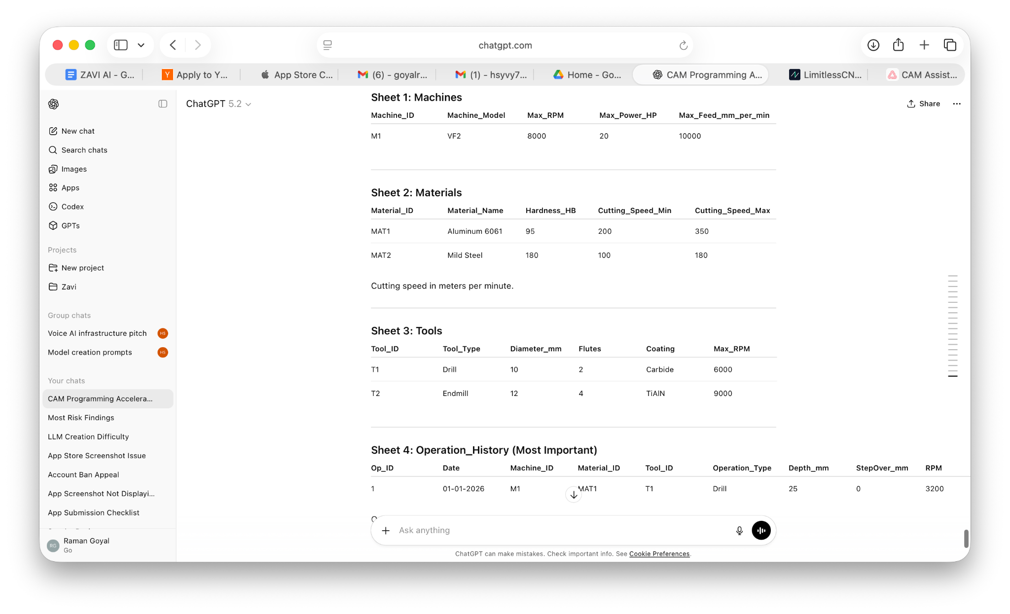

- Action Plan (for Layer 1)
- Finalize One material (Al 6061) + one machine type (VMC 3axis) + one industry first (Aerospace/ drones)
- Build the data flywheel now. Every CAM file + actual cut result + inspection report is gold. Build the platform so shops that use us are feeding us data. This is the real moat — not the software, but the millions of cut-hours of training data.
- Understand difference between LLM and Reinforcement Learning (RL) models

Implementation Approach -
- Generate dataset (synthetic/ public) of CAD files
- For feature recognition, train a HGCNN or similar GNN architecture on the B-Rep graph representation
- Extract geometric dimensions, orientations and stock sizes from recognized features
- Map recognized features to machining operation types (roughing, finishing, drilling)
- Enumerate valid machining strategy trees (operation sequence, tool assignments, approach directions, clamping setups)
- Train a neural network surrogate model to predict strategy quality scores without full simulation and prune from trillions to thousands

- Run a lightweight physics simulation to top candidates to estimate (cycle time, cutting forces, tool deflection,surface finish quality, and tool wear)
- Score strategies using a multi-objective cost function balancing cycle time, tool life, surface quality, and process robustness

// need to ensure machining constraints are also captured somewhere
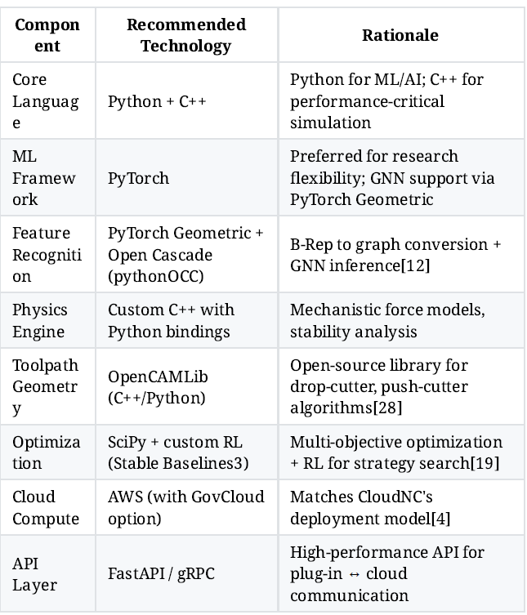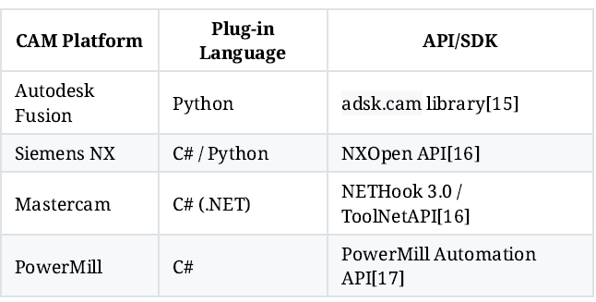

- Next questions
  - Prepare pitch script to vendors to share their data
- Reduce programming time by 50%-60%
- Reduce scrap from programming errors (i.e. reduce material wastage and time wastage in redoing the part)
- Generate accurate quotes in minutes instead of days / hours
  - How to take out the data from the controller? Who will help us with this?
- Developer will help
- Will need to check API integrations for extracting data on continuous basis

  - Which CAM software to focus on? Which Controller to focus on?
- This will depend on whom we partner with.

🔗 Dataset Links with Descriptions

1. Fusion 360 Gallery Dataset
What it's for: Parametric CAD design sequences — 8,625 human-authored CAD models with sketch-and-extrude construction histories, assembly data with joints and contact surfaces. Ideal for training AI on how humans design mechanical parts in CAD software.
- GitHub (Main): https://github.com/AutodeskAILab/Fusion360GalleryDataset
- Documentation: https://github.com/AutodeskAILab/Fusion360GalleryDataset/blob/master/docs/README.md
- Paper (arXiv): https://arxiv.org/abs/2010.02392
- Autodesk Research Page: https://www.research.autodesk.com/publications/fusion-360-gallery/

2. ABC Dataset (A Big CAD Model Dataset)
What it's for: 1 million mechanical CAD parts sourced from Onshape, stored in STEP/STL/OBJ formats. Ground truth for surface normals, patch segmentation, sharp feature detection, and geometric deep learning. Best large-scale source for mechanical part geometry.
- Official Website + Downloads: https://deep-geometry.github.io/abc-dataset/
- GitHub: https://github.com/deep-geometry/abc-dataset
- Paper (arXiv): https://arxiv.org/abs/1812.06216

3. ShapeNet
What it's for: Large-scale repository of annotated 3D CAD models across 3,000+ categories (~220,000 classified models). Used for 3D object recognition, shape retrieval, part segmentation, and general geometric AI research. Covers everyday objects, furniture, vehicles, and more — not limited to mechanical parts.
- Official Website: https://shapenet.org/
- HuggingFace (ShapeNetCore v2): https://huggingface.co/datasets/ShapeNet/ShapeNetCore
- Paper (arXiv): https://arxiv.org/abs/1512.03012
- Papers With Code: https://paperswithcode.com/dataset/shapenet

4. ModelNet (Princeton)
What it's for: 127,915 CAD models across 662 object categories, with a commonly used 40-class subset (ModelNet40). Primarily used as a benchmark for 3D shape classification and retrieval using deep learning. Great for training point cloud or voxel-based models.
- Official Website + Download: https://modelnet.cs.princeton.edu/
- ModelNet40 Direct Download: https://modelnet.cs.princeton.edu/ModelNet40.zip
- Download Page: https://modelnet.cs.princeton.edu/download.html

5. DeepCAD Dataset
What it's for: ~178,000 CAD models with full construction sequence histories (sketch + extrude operations), parsed from Onshape. Used for generative AI models that learn to produce parametric CAD sequences. The go-to dataset for CAD sequence generation research.
- GitHub (Official Code + Dataset): https://github.com/ChrisWu1997/DeepCAD
- Papers With Code: https://paperswithcode.com/dataset/deepcad
- Kaggle Mirror: https://www.kaggle.com/datasets/vitalygladyshev/deepcad

